# INDIAN ECONOMIC GROWTH

A Course Project report submitted

in partial fulfillment of requirement for the award of degree

### BACHELOR OF TECHNOLOGY

in

### ARTIFICIAL INTELLIGENCE AND MACHINE LEARNING

by

### B. SAI CHARAN (2203A51L72)

**SALIM SK (2203A51L53)**

### L. MAMITH (2203A51L29)

Under the guidance of

### Mr. S. NARESH KUMAR

Assistant Professor, Department of CSE.



**Department of Computer Science and Artificial Intelligence**



**Department of Computer Science and Artificial Intelligence**

**CERTIFICATE**

This is to certify that project entitled **“INDIAN ECONOMIC GROWTH**" is the bonafide work carried out by **B.SAI CHARAN(2203A51L72), SALIM SK(2203A51L53), L.MAMITH(2203A51L29)** as a Course Project for the partial fulfillment to award the degree **BACHELOR OF TECHNOLOGY** in **ARTIFICIAL INTELLIGENCE AND**

**MACHINE LEARNING** during the academic year 2022-2023 under our guidance and Supervision.

### Mr. S Naresh Kumar Dr. M.Sheshikala

Asst. Professor, Assoc. Prof. & HOD (CSE)

S R University S R University

Ananthasagar, Ananthasagar,

Warangal. Warangal.

# ACKNOWLEDGEMENT

We express our thanks to Course co-coordinator **Mr. S.Naresh Kumar, Asst. Prof.** for guiding us from the beginning through the end of the Course Project. We express our gratitude to Head of the department CS&AI, **Dr. M.Sheshikala, Associate Professor** for encouragement, support and insightful suggestions. We truly value their consistent feedback on our progress, which was always constructive and encouraging and ultimately drove us to the right direction.

We wish to take this opportunity to express our sincere gratitude and deep sense of respect to our beloved Dean, School of Computer Science and Artificial Intelligence, **Dr C.**

**V. Guru Rao**, for his continuous support and guidance to complete this project in the institute.

Finally, we express our thanks to all the teaching and non-teaching staff of the department for their suggestions and timely support.

# ABSTRACT

This paper provides an outlook for the Indian economy in the light of the extraordinary global financial crisis, that started in the US, but which has now transformed into the worst economic downturn since the Great Depression. The Indian economy was slowing down even before the onset of global crisis and so the timing of this external shock could not have been worse. The analysis undertaken for this paper shows that the global crisis is likely to bring the Indian GDP growth rate down considerably. This will pose a big challenge requiring urgent and sustained policy attention to prevent this downturn from becoming unnecessarily prolonged. There is real downside risk that the growth rate could plummet to the pre-1980s levels if appropriate countercyclical measures are not taken immediately and are not urgently followed by necessary structural reforms. The paper provides a short-term forecast for GDP growth based on a model of leading economic indicators. We present three scenarios in the paper assuming differentiated impact of the external crisis. Finally the paper suggests a set of policy measures to get the Indian economy back on the path of sustained rapid and inclusive growth.

# Table of Contents

## Chapter No. Title Page No

1. Introduction
   1. Overview 1
   2. Problem Statement 1
   3. Existing system 1
   4. Proposed system 2
   5. Objectives 2
2. Literature survey

2.1.1. Related Work 3

1. Data pre-processing
   1. Dataset description 7
   2. Data cleaning 8
   3. Data Visualization 12
2. Methodology
   1. Procedure to solve the given problem 24
   2. Model architecture 25
   3. Software description 25
3. Results and discussion 26
4. Conclusion and future scope 27
5. References 28

# LIST OF FIGURES

|  |  |  |
| --- | --- | --- |
| **S.NO** | **FIGURE NAME** | **PAGE NO** |
| 1 | UML diagram | 2 |
| 2 | Visualization | 12 |

**LIST OF TABLES**

|  |  |  |
| --- | --- | --- |
| **S.NO** | **TABLE NAME** | **PAGE NO** |
| Table 1 | Results table | 26 |

## Overview

# INTRODUCTION

Strong economic growth in the first quarter of FY 2022-23 helped India overcome the UK to become the fifth-largest economy after it recovered from repeated waves of COVID- 19 pandemic shock. Real GDP in the first quarter of 2022–23 is currently about 4% higher than its corresponding 2019-20, indicating a strong start for India's recovery from the pandemic. Given the release of pent-up demand and the widespread vaccination coverage, the contact-intensive services sector will probably be the main driver of development in 2022–2023. Rising employment and substantially increasing private consumption, supported by rising consumer sentiment, will support GDP growth in the coming months.

## Existing Economy

India’s nominal gross domestic product (GDP) at current prices is estimated to be at Rs. 232.15 trillion (USD$ 3.12 trillion) in FY22. With more than 100 unicorns valued at USD$ 332.7 billion, India has the third-largest unicorn base in the world. The government is also focusing on renewable sources to generate energy and is planning to achieve 40% of its energy from non-fossil sources by 2030. India is primarily a domestic demand-driven economy, with consumption and investments contributing to 70% of the economic activity. With an improvement in the economic scenario and the Indian economy recovering from the Covid-19 pandemic shock, several investments and developments have been made across various sectors of the economy.

## Problem system

The Indian economy growth could be to develop a predictive model that can analyze various economic indicators and provide insights into the factors that influence the growth of the Indian economy. The model can use a range of data sources such as GDP growth rates, inflation rates, employment data, demographic trends, and market trends to identify key drivers of growth in the Indian economy. The model can then be used to forecast future

growth trends and suggest policy interventions that can stimulate growth and address the challenges facing the economy. The objective of this project is to help policymakers and business leaders make informed decisions that can drive sustainable economic growth and improve the overall well-being of citizens.

## Object definition

The model can then be used to forecast future growth trends and suggest policy interventions that can stimulate growth and address the challenges facing the economy. The objective of this project is to help policymakers and business leaders make informed decisions that can drive sustainable economic growth and improve the overall well-being of citizens.

## UML diagram

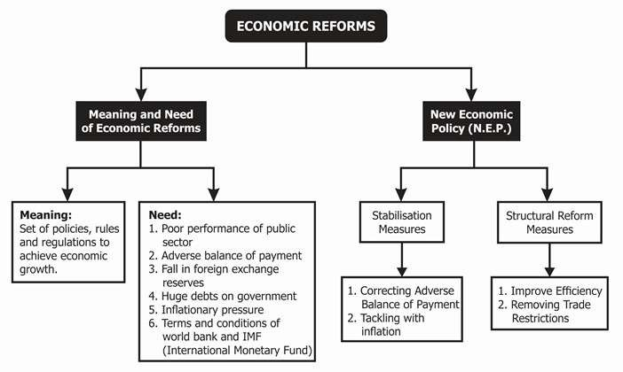

FIG 1.1

# LITERATURE SURVEY

## Related work

### Python

Python is an interpreted, high-level, general purpose programming language.

Python’s design philosophy emphasizes code readability with its notable use of significant white space. It’s language constructs, object oriented approach aim to help programmers write clear, logical code for small and large scale projects. Python is dynamically typed and supports multiple programming paradigms, including procedural, object oriented, and functional programming.

### Google Colab

Google Collaboratory is a free Jupiter notebook environment that runs on Google Cloud service, letting the user leverage bag and hardware like GPU and TPUs. This lets you do everything you can in a Jupiter notebook hosted in your local machine without requiring the installation and setup for hosting a notebook in your local machine. The configuration increases if you want to perform specialized tasks such as machine learning, computation, analysis, data exploration. Again, the question arises of whether your system has a supported GPU to train machine learning models. Google Colab is a free online platform provided by Google that allows users to write and run Python code collaboratively in a Jupyter notebook environment. It provides access to free cloud-based computing resources such as CPUs, GPUs, and TPUs to run code, making it a useful tool for machine learning and data analysis.

Google Colab can be accessed using a Google account and does not require any installation or setup. It is a popular platform for teaching and learning data science, as well as for sharing and collaborating on code.

### State of the economy:

In general, global economic shocks in the past were severe but spaced out in time. This changed in the third decade of this millennium. At least three shocks have hit the global economy since 2020. It all started with the pandemic-induced contraction of the global output, followed by the Russian-Ukraine conflict leading to a worldwide surge in inflation. Then, the central banks across economies led by the Federal Reserve responded with synchronised policy rate hikes to curb inflation. The rate hike by the US Fed drove capital into the US markets causing the US Dollar to appreciate against

most currencies. This led to the widening of the Current Account Deficits (CAD) and increased inflationary pressures in net importing economies. The rate hike and persistent inflation also led to a lowering of the global growth forecasts for 2022 and 2023 by the IMF in its October 2022 update of the World Economic Outlook. The frailties of the Chinese economy further contributed to weakening the growth forecasts. Slowing global growth apart from monetary tightening may also lead to a financial contagion emanating from the advanced economies where the debt of the non-financial sector has risen the most since the global financial crisis. With inflation persisting in the advanced economies and the central banks hinting at further rate hikes, downside risks to the global economic outlook appear elevated. The Indian economy, however, appears to have moved on after its encounter with the pandemic, staging a full recovery in FY22 ahead of many nations and positioning itself to ascend to the pre-pandemic growth path in FY23. Yet in the current year, India has also faced the challenge of reining in inflation that the European strife accentuated.

Despite these, agencies worldwide continue to project India as the fastest-growing major economy at 6.5-7.0 per cent in FY23. These optimistic growth forecasts stem in part from the resilience of the Indian economy seen in the rebound of private consumption seamlessly replacing the export stimuli as the leading driver of growth. The uptick in private consumption has also given a boost to production activity resulting in an increase in capacity utilisation across sectors. The rebound in consumption was engineered by the near-universal vaccination coverage overseen by the government that brought people.

Growth is inclusive when it creates jobs. Both official and unofficial sources confirm that employment levels have risen in the current financial year. The Periodic Labour Force Survey (PLFS) shows that the urban unemployment rate for people aged 15 years and above declined from 9.8 per cent in the quarter ending September 2021 to 7.2 per cent one year later (quarter ending September 2022). This is accompanied by an improvement in the labour force participation rate (LFPR) as well, confirming the emergence of the economy out of the pandemicinduced slowdown early in FY23. Job creation appears to have moved into a higher orbit with the initial surge in exports, a strong release of the “pent-up” demand, and a swift rollout of the capex. Since export growth is plateauing and the “pent-up” release of demand will have a finite life, it is

essential that capex continues to grow to facilitate employment in the economy, at least until such time the global economy rebounds and, through the export channel, provides an additional window to India for job creation. Thankfully, the private sector has all the necessary pre-conditions lined up to step up to the plate and do the capex heavy lifting. Their internal resource generation is good, capacity utilisation is high, and the demand outlook continues to improve. Capital markets are willing to finance new investments, as are financial institutions.

### Gdp Growth:

For India, 2022 was special. It marked the 75th year of India’s Independence. India became the world’s fifth largest economy, measured in current dollars. Come March, the nominal GDP of India will be around US$ 3.5 trillion. In real terms, the economy is expected to grow at 7 per cent for the year ending March 2023. This follows an 8.7 per cent growth in the previous financial year. The rise in consumer prices has slowed considerably. The annual rate of inflation is below 6 per cent. Wholesale prices are rising at a rate below 5 per cent. The export of goods and services in the first nine months of the financial year (April – December) is up 16 per cent compared to the same period in 2021-22. Although the high oil price this year compared to last inflated India’s import bill and caused the merchandise trade deficit to balloon, concerns over the current account deficit and its financing have ebbed as the year rolled on. Foreign exchange reserve levels are comfortable and external debt is low.

### Inflation Rate:

The Economic Survey 2022-23 comes when global uncertainties are rife. Barely had the pandemic receded, and the war in Ukraine broke out in February 2022. Prices of food, fuel and fertiliser rose sharply. As inflation rates accelerated, central banks of advanced countries scrambled to respond with monetary policy tightening. Many developing countries, particularly in the South Asian region, faced severe economic stress as the combination of weaker currencies, higher import prices, the rising cost of living and a stronger dollar, making debt servicing more expensive, proved too much to handle. In the second half of 2022, there was a respite for governments and households. Commodity prices peaked and then declined. In the near term, the acute pressure was relieved, although prices of some commodities (e.g., crude oil) remain

well above their pre-pandemic levels. For countries dependent on imports, priced and payable in dollars, a global slowdown led by the United States (US) offers a triple relief. Commodity prices decline, and US interest rates peak, as does the US dollar. Capital and current account imbalances abate. As 2023 rolled in, China opened up rather swiftly, reversing its Zero-Covid policy. An unexpectedly warm winter that has spared households from a debilitating increase in fuel prices that would have dented their disposable income significantly has stirred hopes that the Eurozone economies would narrowly avoid a recession. As the headline inflation rate declines in the US, policy rates are set to rise more slowly. In anticipation, bond yields have come down, and there

are faint hopes of the US avoiding a recession altogether, barring any unexpected financial system stress.

### Factors:

Economists generally agree that economic factors affecting economic growth and development are: human resources, physical capital, natural resources, technology development, entrepreneurship, population growth and social overheads.

1. Natural Resources
2. GDP Growth Rate
3. Inflation Rate
4. Import Value
5. Export Value
6. Unemployment
7. Capital Formation
   1. **Data set**

# DATA PRE-PROCESSING

**Date:-** Date refers to the time period where the Indian Economy is taken.

**GDP Growth:-** GDP is the sum of gross value added by all resident producers in the economy plus any product taxes and minus any subsidies not included in the value of the products. It is calculated without making deductions for depreciation of fabricated assets or for depletion and degradation of natural resources.

**Inflation Rate:-** In economics, inflation is an increase in the general price level of goods and services in an economy. When the general price level rises, each unit of currency buys fewer goods and services; consequently, inflation corresponds to a reduction in the purchasing power of money.

**GDP Billon USD:-** Gross domestic product (GDP) is the total monetary or market value of all the finished goods and services produced within a country's borders in a specific time period. As a broad measure of overall domestic production, it functions as a comprehensive scorecard of a given country's economic health.

**Export Value Billion USD:-** The value of goods exported to a foreign country by residents according to international trade statistics.

**Import Value Billion USD:-** With exports worth $453 billion and imports to the tune of

$723 billion, India's overall international trade reached $1.17 trillion, 21% above previous year's $969 billion, official data show.

**Unemployment:-** The unemployment rate is the percentage of the labor force that is looking for a job. The labor force is only a portion of the total population. The ratio of the labor force to the working-age population is called the labor force participation rate.

* 1. **Data cleaning**

Dropping the null values was not an option since it negatively affected the accuracy. These null values were handled by replacing them with the median value of the column. The replacement was done by implementing the simple function in the pipeline itself. So that any missing value in the future would be handled as soon as the data passes through the pipeline.

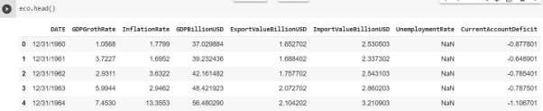

The above are the Head of the dataset.

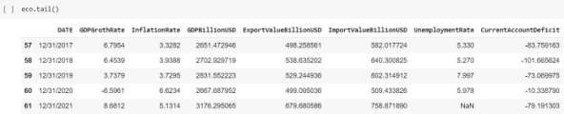

The above are the Tail of the dataset.

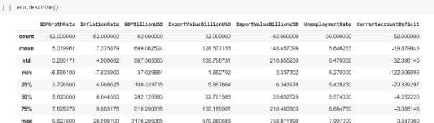

The above command Describes the dataset.

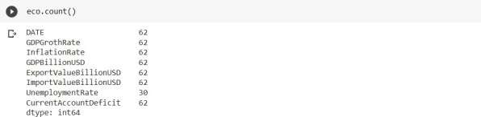

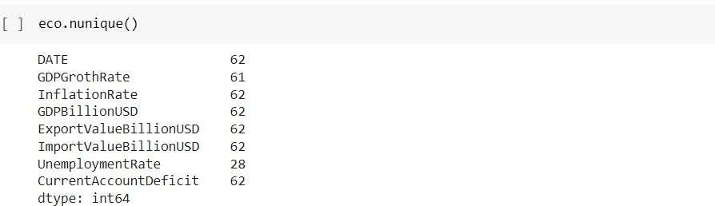

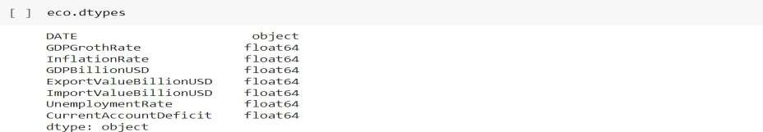

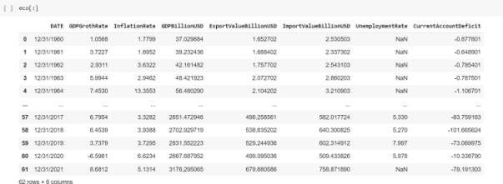

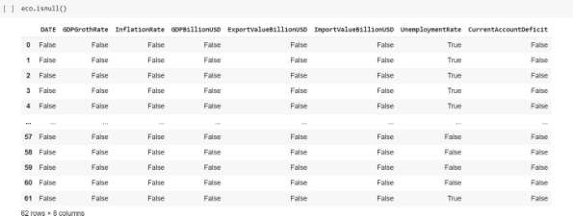

## DATASET:

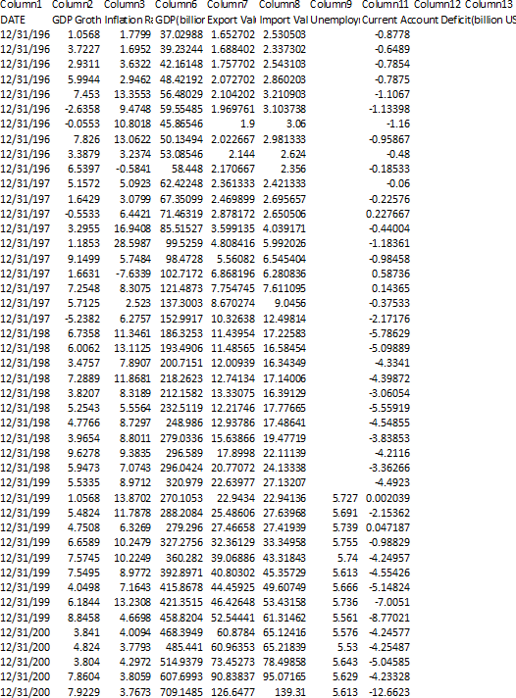

The above is the dataset (.csv) file

## Data visualization

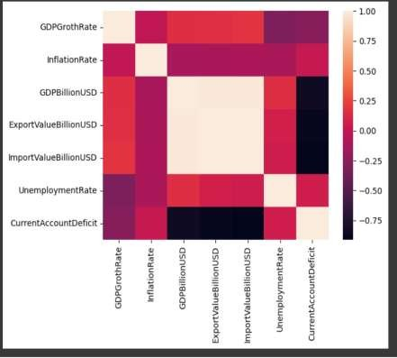

**Fig-1**

HEATMAP OF ECONOMIC

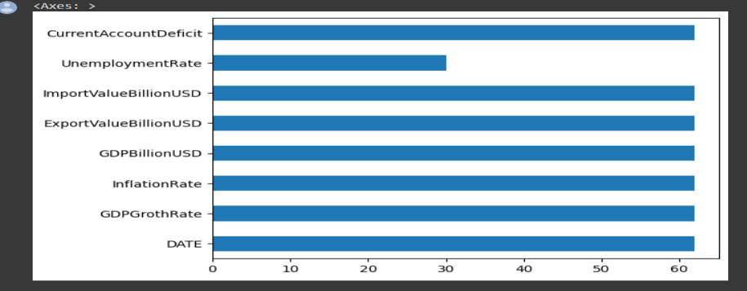

Fig-2(Plot Barh)

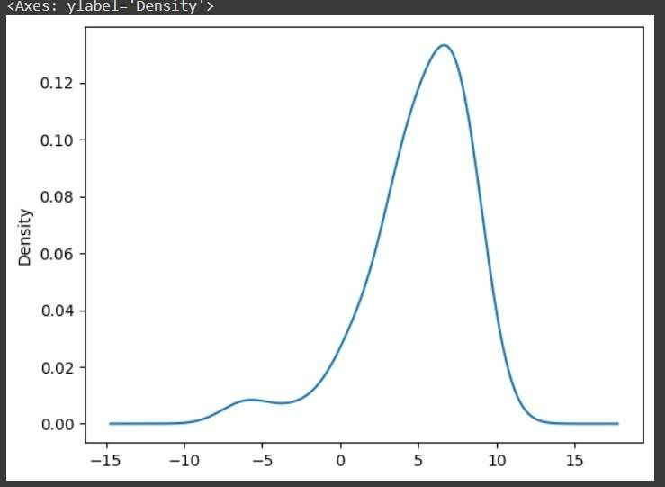

Fig-3(Plot Density)

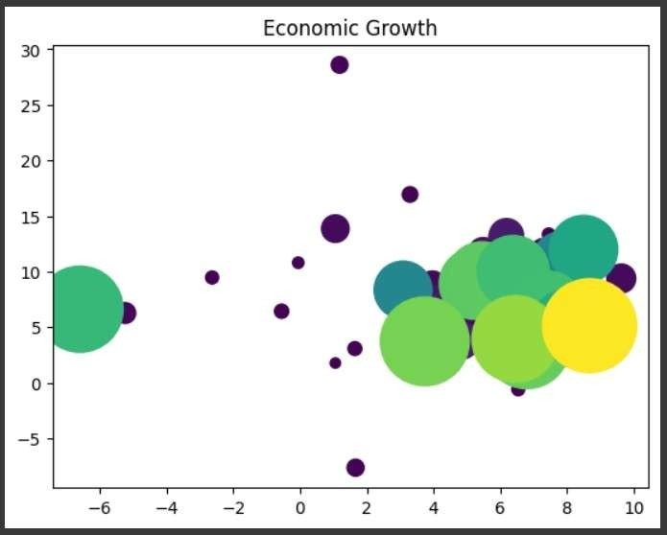

Fig-4(Scatter Plot)

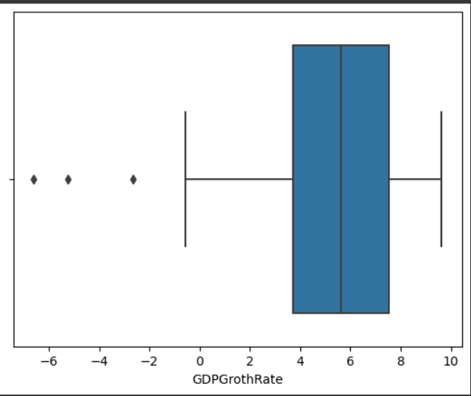

Fig-5(Box Plot)

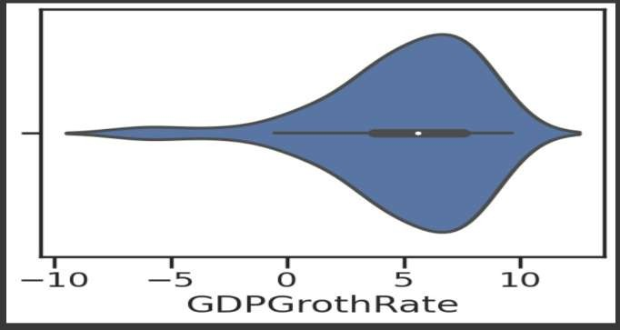

Fig-6(Violin Plot)

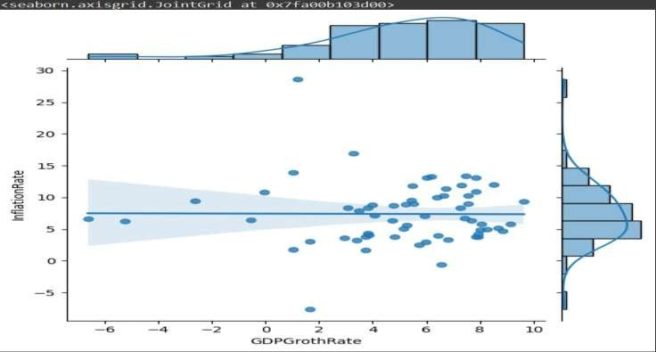

Fig-7(Joint Plot)

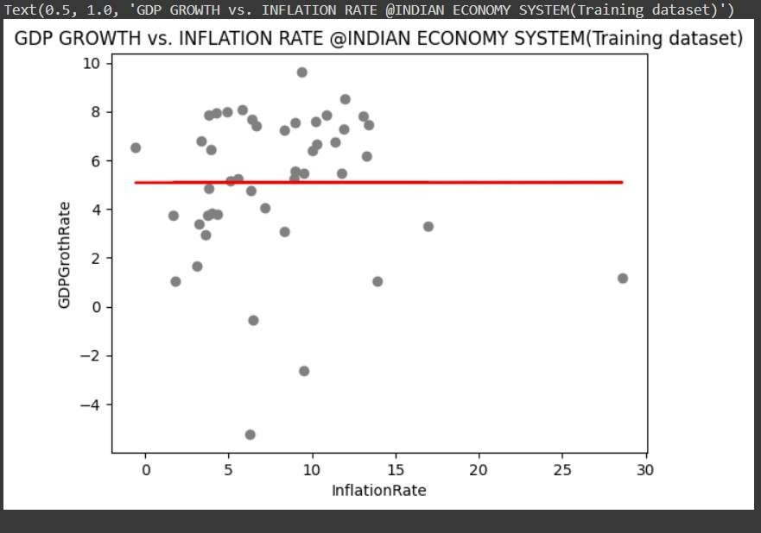

## Fig-8( Training Dataset)

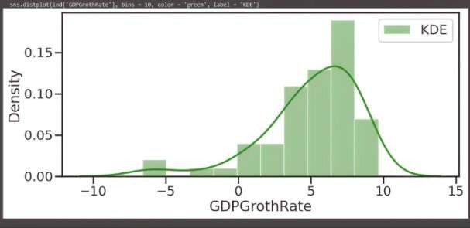

**Fig-9(Dist Plot)**

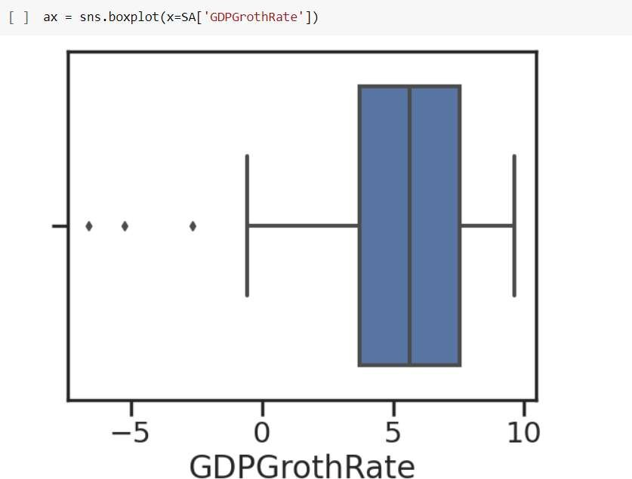

**Fig-10**

The above is the Box Plot of “GDP Growth Rate”

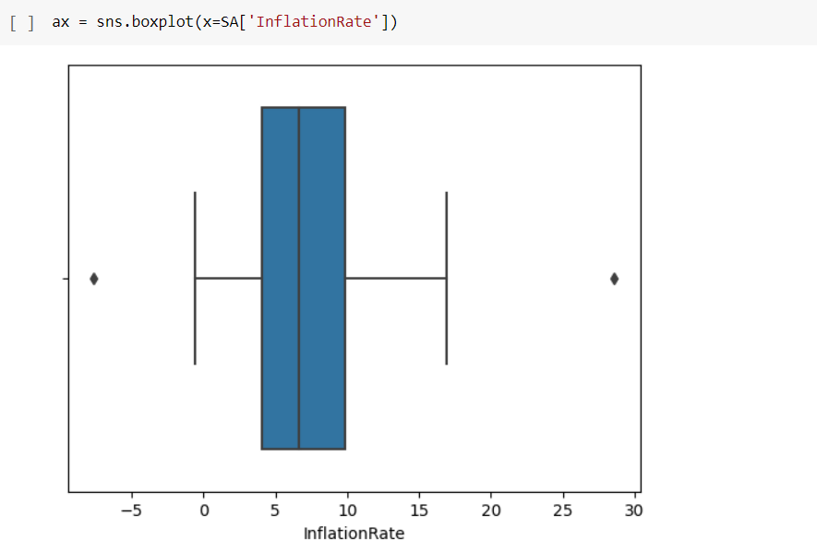

### Fig-11

The above is the Box Plot of “Inflation Rate”

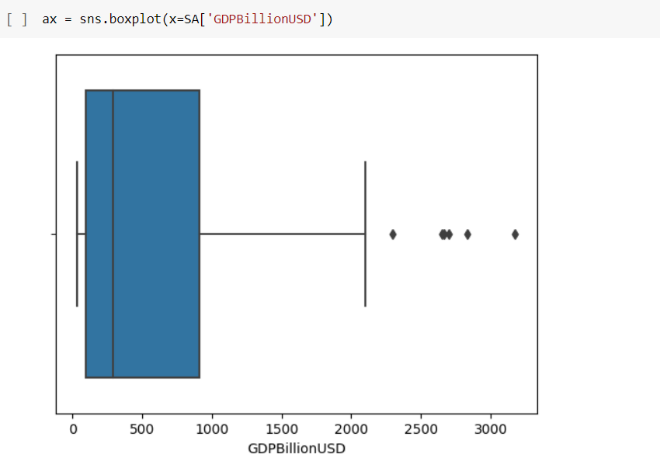

# Fig-12

The above is the Box Plot of “GDP Billion USD”

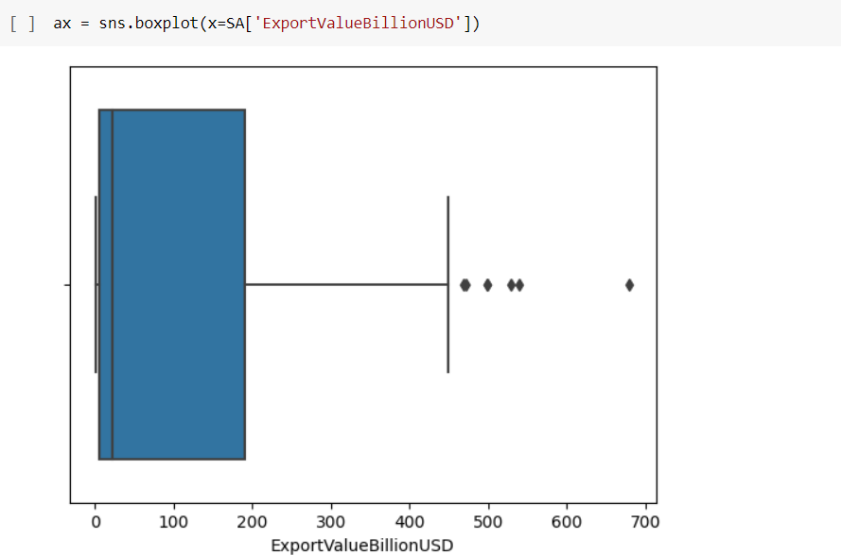

# Fig-13

The above is the Box Plot of “ExportValueBillionUSD”

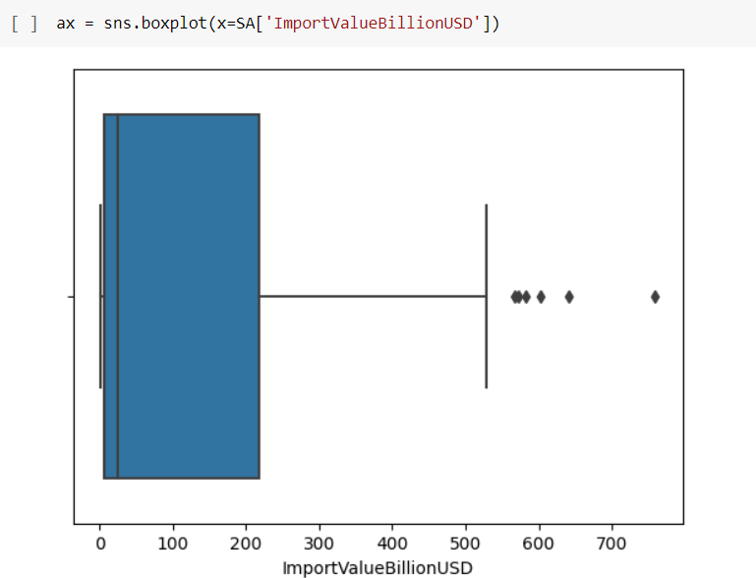

# Fig-14

The above is the Box Plot of “ImportValueBillionUSD”

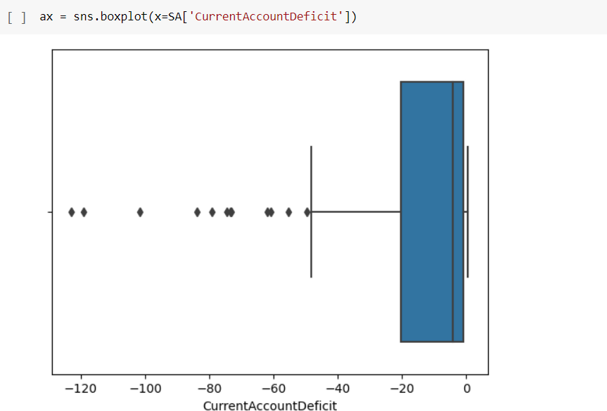

# Fig-15

The above is the Box Plot of “CurrentAccountDeficit”

**CALCULATION:**

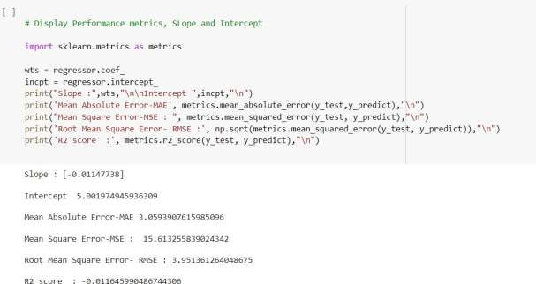

# Fig-16

The above gives the SLOPE , INTERCEPT, MEAN ABSOLUTE ERROR, MEAN SQUARE, ROOT MEAN SQUARE ERROR, R2 SCORE.

# METHODOLOGY

* 1. **Procedure to solve the problem** 1.Download data set in CSV form. 2.Upload to Google Drive.

1. Connect Google Drive to Google colab.
2. Loading the data from CSV files to pandas data frame. 5.Understanding the data.
3. Checking missing values.
4. Checking distribution of categorical values. 8.Encoding certain columns.

9.Display linear regression model manually. 10.Set the best possible equation.

11. Obtain the main error for comparison and further study.

If possible, find which feature variable is affecting the target variable.

## Models used

Linear regression model

## Software description

In our program we use Python 3 programming language. Python interpreted object oriented high level programming language with dynamic semantics. It’s high level built in data structures combined with dynamic typing and dynamic building make it very attractive for rapid application development as well As for use as a scripting or glue language to connect existing components together. Pythons. Simply easy to learn syntax emphasizes readability and therefore reduces the cost of program maintenance. Python support modules

and packages which encourages program modularity and code review. The Python interpreter and the extensive standard library are available in source or binary form without charge for all major platforms, and can be free distributed.

**MODEL ARCHITECTURE**

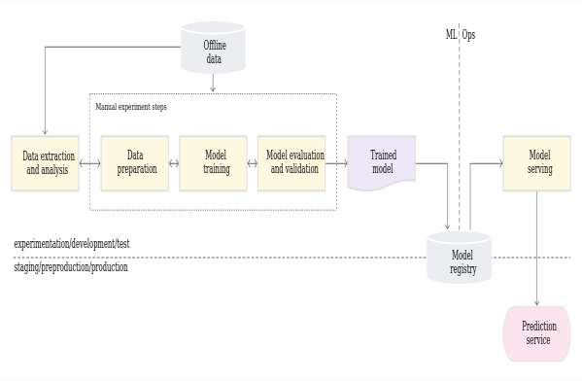

# RESULTS AND DISCUSSION

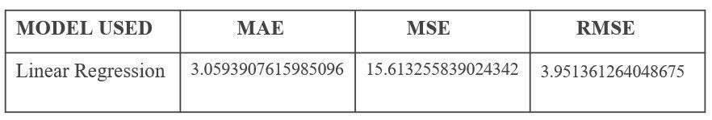

Table1(results table)

# CONCLUSION

The Indian government's push towards economic reforms and initiatives such as "Make in India" and "Digital India" are expected to stimulate growth in the manufacturing and services sectors, respectively. Additionally, the increasing adoption of digital technologies and the expansion of e-commerce are likely to further boost the economy.

However, India's economic growth could face challenges such as rising inflation, unemployment, and the ongoing COVID-19 pandemic. These factors could potentially slow down the growth rate, and it will be important for the government to implement measures to address these issues.

Overall, while there may be some challenges, the Indian economy is expected to continue growing and expanding in the years to come.

# REFERENCES

* <https://www.kaggle.com/code/sahargarmsiri/linear-regression>
* <https://www.kaggle.com/code/shubhamsinghgharsele/analysis-on-indian-import-export>
* [https://www.imf.org/external/datamapper/PPPEX@WEO/OEMDC/ADVEC/WEOWOR](https://www.imf.org/external/datamapper/PPPEX%40WEO/OEMDC/ADVEC/WEOWOR) LD/IND